try-with-resources
Support for try-with-resources — introduced in Java 7(JDK7)
The try-with-resources statement is a Java feature ensures that resources are automatically closed after they are used. This can help to prevent resource leaks and other problems.
The try-with-resources statement takes a block of code as its argument. The block of code can contain any number of resources, which can be declared anywhere in the block. The resources will be closed in the reverse order in which they were declared.
The try-with-resources statement is a convenient way to ensure that resources are properly closed. It can help to improve the readability and maintainability of your code.
The try-with-resources statement is a powerful tool that can help you to write more reliable and maintainable code.
Scanner scanner = null;
try {
scanner = new Scanner(new File("test.txt"));
while (scanner.hasNext()) {
System.out.println(scanner.nextLine());
}
} catch (FileNotFoundException e) {
e.printStackTrace();
} finally {
if (scanner != null) {
scanner.close();
}
}

And here’s the new solution using try-with-resources:
try (Scanner scanner = new Scanner(new File("test.txt"))) {
while (scanner.hasNext()) {
System.out.println(scanner.nextLine());
}
} catch (FileNotFoundException fnfe) {
fnfe.printStackTrace();
}
import java.io.*;

// Class
class GFG {

// Main driver method
public static void main(String[] args)
{
try (FileOutputStream fos
= new FileOutputStream("outputfile.txt");

// Reading the stream of character from
BufferedReader br = new BufferedReader(
new FileReader("gfgtextfile.txt"))) {

String text;

while ((text = br.readLine()) != null) {

byte arr[] = text.getBytes();

// String converted to bytes
fos.write(arr);

}
System.out.println("File content copied to another one.");
}

// Catch block to handle generic exceptions
catch (Exception e) {

// Display the exception on the
// console window
System.out.println(e);
}

// Display message for successful execution of the
// program
System.out.println(
"Resource are closed and message has been written into the gfgtextfile.txt");
}
}
Output:
File content copied to another one.
Resource are closed and message has been written into the gfgtextfile.txt

Example2:

try (
FileInputStream fis = new FileInputStream("myfile.txt");
BufferedReader br = new BufferedReader(fis)
) {
String line;
while ((line = br.readLine()) != null) {
System.out.println(line);
}
} catch (IOException e) {
e.printStackTrace();
}

Streams
- Java performs I/O through streams
- A stream in programming means the flow of data.
- It is basically a sequence of data.
- A stream in java is a path along which data flows (like pipe along which water flows). It has source (of data) and destination (for that data).
- Whatever data we use in our programming flows through a stream.
- A stream can be defined as a sequence of data. There are two kinds of Streams
  - InPutStream − The InputStream is used to read data from a source.
  - OutPutStream − The OutputStream is used for writing data to a destination.
- Input stream means generating a sequence of bytes from the keyboard, file or network, etc.
- Output stream means a sequence of bytes holding output for data consumers. The data consumer can be a monitor, a file, or a printer.
Standard Streams
All the programming languages provide support for standard I/O where the user's program can take input from a keyboard and then produce an output on the computer screen. Java provides the following three standard streams –
Standard Input − This is used to feed the data to user's program and usually a keyboard is used as standard input stream and represented as System.in.
Standard Output − This is used to output the data produced by the user's program and usually a computer screen is used for standard output stream and represented as System.out.
Standard Error − This is used to output the error data produced by the user's program and usually a computer screen is used for standard error stream and represented as System.err.
STREAM CLASSES
The java.io package contains a large number of stream classes that provide capabilities for processing all types of data.
The classes may be categorized into two groups based on the data type on which they operate.
- Byte Streams
- Character Streams

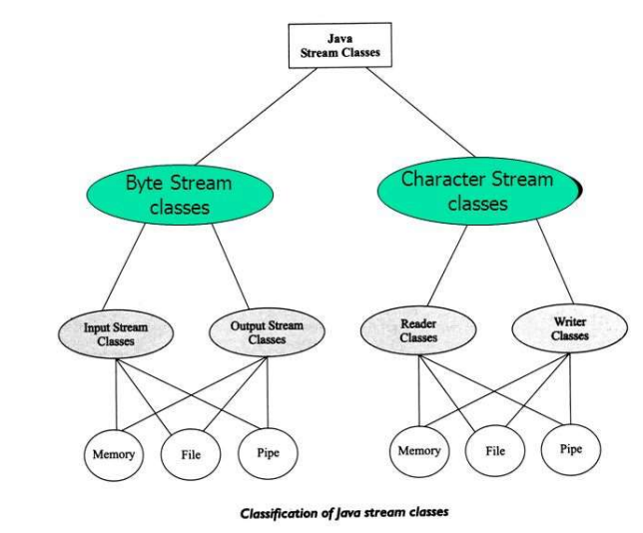
Byte Streams
- Java byte streams are used to perform input and output of 8-bit bytes.

- These are used when reading or writing binary data.

- Byte stream classes have been designed to provide functional features for creating and manipulating streams and files reading and writing bytes.

- Since the steams are unidirectional, they can transmit bytes in only one direction and, therefore, Java provides two kinds of byte stream classes:
  - input stream classes
  - output stream classes.
Input Stream Classes
Input stream classes that are used to read 8-bit bytes include super class known as InputStream and a number of subclasses for supporting various input-related functions.
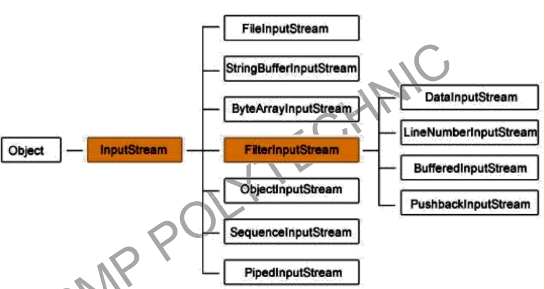
Though there are many classes related to byte streams but the most frequently used classes
are, FileInputStream and FileOutputStream.

OUTPUT STREAM CLASSES
Output stream classes are derived from the base class OutputStream
Like InputStream, the OutputStream is an abstract class and therefore we cannot instantiate it. The several subclasses of the OutputStream can be used for performing the output operations.
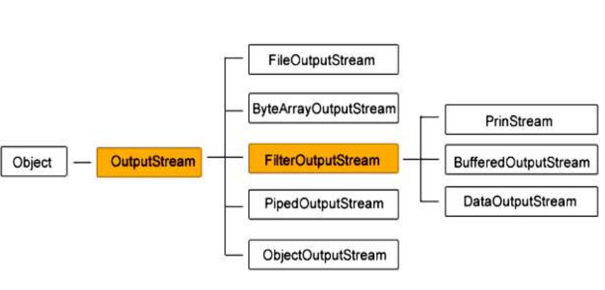
Character streams
- Java Character streams are used to perform input and output for 16-bit Unicode.
- They can perform operations on characters, char arrays and Strings.
- The CharacterStream classes are mainly used to read characters from the source and write them to the destination.
- For this purpose, the CharacterStream classes are divided into two types of classes
- Reader class
- Writer class.
Reader classes
- Reader classes are designed to read characters from the files.
- Reader class is the base class for all other classes in this group.
- These classes are functionally very similar to the input stream classes, except input stream use bytes as their fundamental unit of information, while reader stream use characters.
- The Reader class contains method they are identical to those available in the InputStream class, except Reader is designed to handle characters. Therefore, reader classes can perform all the functions implemented by the input stream classes.
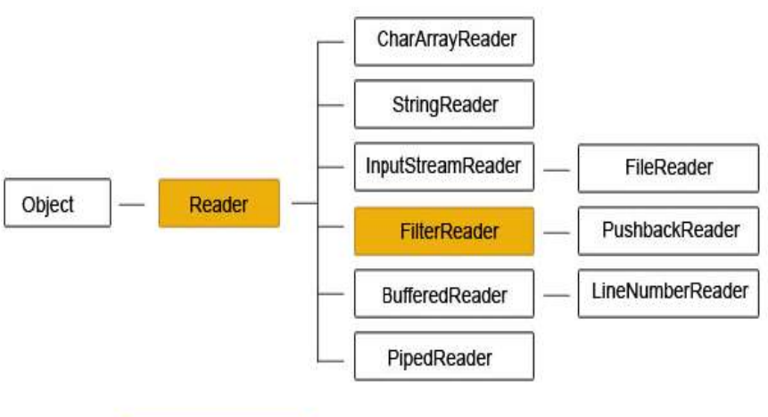
Writer Classes
- Like output stream classes, the writer classes are designed to perform all output operations on files.
- Only difference is that while output stream classes are designed to write bytes, the writer stream classes are designed to write characters.
- The Writer class is an abstract class which acts as a base class for all other writer stream classes.
- This base class provides support for all output operations by defining method that are identical to those in OutputStream class.
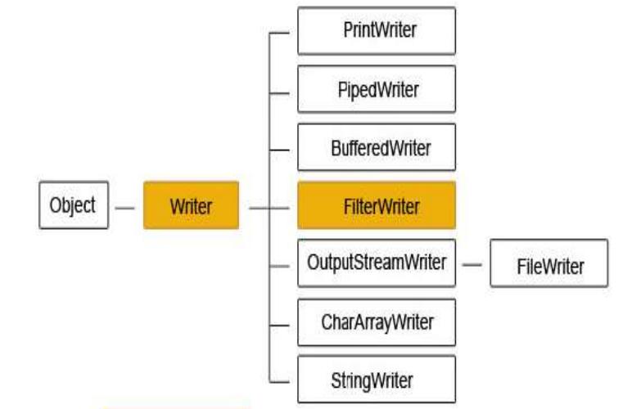

USING STREAMS
- We have types of input and output stream classes used for handling both the 16-bit characters and 8-bit bytes. Although all the classes are known as i/o classes, not all of them are used for reading and writing operations only.
- Some perform operations such as buffering, filtering, data conversion, counting and concatenation while carrying out I/O tasks.
- As pointed out earlier, both the character stream group and the byte stream group contain parallel pairs of classes that perform the same of operations but for the different data type.
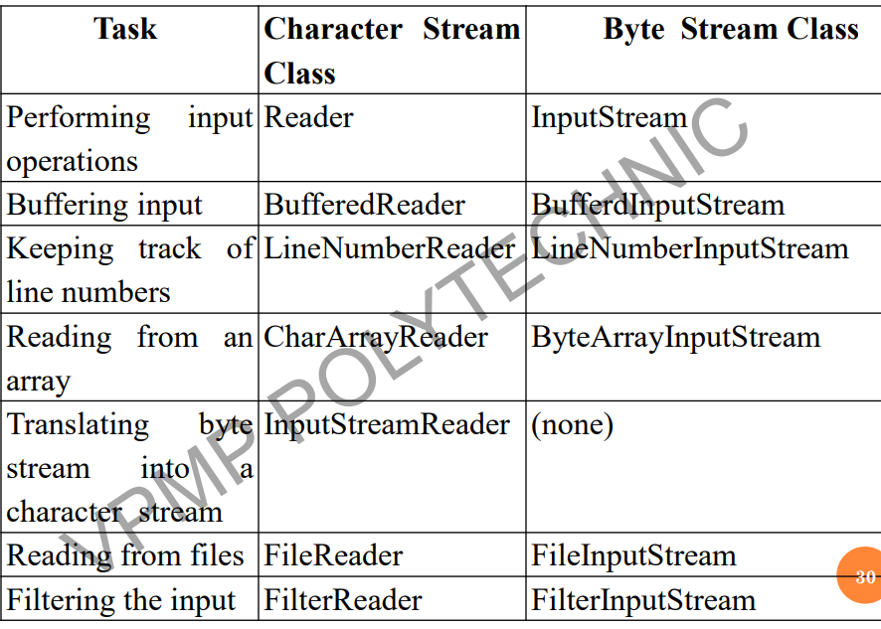

Reading Console Input
- In Java 1.0, the only way to perform console input was to use a byte stream.
- The preferred method of reading console input is to use a character-oriented stream, which makes your program easier to internationalize and maintain.
- In Java, console input is accomplished by reading from System.in.
- To obtain a character based stream that is attached to the console, wrap System.in in a BufferedReader object.
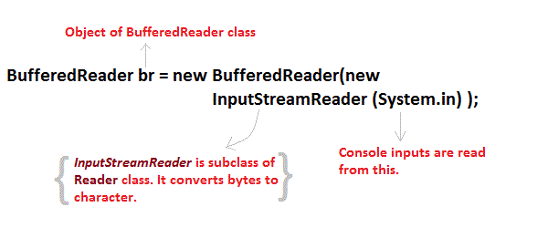
Reading Characters
To read a character from a BufferedReader, use read( ) function.
int read( ) throws IOException
Each time that read( ) is called, it reads a character from the input stream and returns it as an integer value. It returns –1 when the end of the stream is encountered. It can throw an IOException
// Use a BufferedReader to read characters from the console.
import java.io.*;
class BRRead {
public static void main(String args[]) throws IOException
{
char c;
BufferedReader br = new BufferedReader(new
InputStreamReader(System.in));
System.out.println("Enter characters, 'q' to quit.");
do {
c = (char) br.read();
System.out.println(c);
} while(c != 'q');
}
}
Here is a sample run:
Enter characters, 'q' to quit.
123abcq
1
2
3
a
b
c
q

Reading Strings
To read a string from the keyboard, use the version of readLine( ) that is a member of the
Buffered Reader class.

// Read a string from console using a BufferedReader.
import java.io.*;
class BRReadLines {
public static void main(String args[])
throws IOException
{
// create a BufferedReader using System.in
BufferedReader br = new BufferedReader(new
InputStreamReader(System.in));
String str;
System.out.println("Enter lines of text.");
System.out.println("Enter 'stop' to quit.");
do {
str = br.readLine();
System.out.println(str);
} while(!str.equals("stop"));
}
}

Note:
- readLine() function returns every value as a string, to read other types we need to parse them to convert to appropriate datatype
- to convert to integer use parseInt()
- similarly use parseFloat(), parseDouble() etc

Writing Console Output
- Console output is most easily accomplished with print( ) and println( )
- PrintStream is an output stream derived from OutputStream, it also implements the low-level method write( ).
- write( ) can be used to write to the console.
// Demonstrate System.out.write().
class WriteDemo {
public static void main(String args[]) {
int b;
b = 'A';
System.out.write(b);
System.out.write('\n');
}
}
You will not often use write( ) to perform console output because print( ) and println( ) are substantially easier to use.

File class
- Java provides a number of classes and methods that allow you to read and write files.
- In Java, all files are byte-oriented, and Java provides methods to read and write bytes from and to a file.
- The File Class from the java.io package plays a crucial role in file manipulation.
- By creating an object of this class and specifying the file's name, we can effectively work with files.
- In order to use the File class, you need to create an object of the class and specify the filename or directory name.
File obj = new File("filename.txt");

Java File Class Methods
The following table depicts several File Class methods:
Method Name | Description | Return Type
canRead() | It tests whether the file is readable or not. | Boolean
canWrite() | It tests whether the file is writable or not. | Boolean
createNewFile() | It creates an empty file. | Boolean
delete() | It deletes a file. | Boolean
exists() | It tests whether the file exists or not. | Boolean
length() | Returns the size of the file in bytes. | Long
getName() | Returns the name of the file. | String
list() | Returns an array of the files in the directory. | String[]
mkdir() | Creates a new directory. | Boolean
getAbsolutePath() | Returns the absolute pathname of the file. | String

File Operations in Java
Basically, you can perform four operations on a file. They are as follows:

- Create a File
- Get File Information
- Write To a File
- Read from a File
Now, let’s get into the details of each of these operations

1. Create a File
In this case, to create a file you can use the createNewFile() method.
This method returns true if the file was successfully created, and false if the file already exists.
Note: the method is enclosed in a try...catch block. This is necessary because it throws an IOException if an error occurs

import java.io.File; // Import the File class
import java.io.IOException; // Import the IOException class to handle errors
public class CreateFile {
public static void main(String[] args) {
try {
File myObj = new File("filename.txt");
if (myObj.createNewFile()) {
System.out.println("File created: " + myObj.getName());
} else {
System.out.println("File already exists.");
}
} catch (IOException e) {
System.out.println("An error occurred.");
e.printStackTrace();
}
}
}

Write To a File
We use the FileWriter class together with its write() method to write some text to the file.
Note that when you are done writing to the file, you should close it with the close() method:
import java.io.FileWriter; // Import the FileWriter class
import java.io.IOException; // Import the IOException class to handle errors
public class WriteToFile {
public static void main(String[] args) {
try {
FileWriter myWriter = new FileWriter("filename.txt");
myWriter.write("Files in Java might be tricky, but it is fun enough!");
myWriter.close();
System.out.println("Successfully wrote to the file.");
} catch (IOException e) {
System.out.println("An error occurred.");
e.printStackTrace();
}
}
}
Read from a File: We will use the Scanner class in order to read contents from a file.
import java.io.File; // Import the File class
import java.io.FileNotFoundException; // Import this class to handle errors
import java.util.Scanner; // Import the Scanner class to read text files
public class ReadFile {
public static void main(String[] args) {
try {
File myObj = new File("filename.txt");
Scanner myReader = new Scanner(myObj);
while (myReader.hasNextLine()) {
String data = myReader.nextLine();
System.out.println(data);
}
myReader.close();
} catch (FileNotFoundException e) {
System.out.println("An error occurred.");
e.printStackTrace();
}
}
}
Delete a File
To delete a file in Java, use the delete() method:

import java.io.File; // Import the File class

public class DeleteFile {
public static void main(String[] args) {
File myObj = new File("filename.txt");
if (myObj.delete()) {
System.out.println("Deleted the file: " + myObj.getName());
} else {
System.out.println("Failed to delete the file.");
}
}
}

Program to demonstrate the usage of different functions
import java.io.File; // Import the File class
public class GetFileInfo {
public static void main(String[] args) {
File myObj = new File("filename.txt");
if (myObj.exists()) {
System.out.println("File name: " + myObj.getName());
System.out.println("Absolute path: " + myObj.getAbsolutePath());
System.out.println("Writeable: " + myObj.canWrite());
System.out.println("Readable: " + myObj.canRead());
System.out.println("File size in bytes: " + myObj.length());
} else {
System.out.println("The file does not exist.");
}
}
}

Random Access Files
- Random access files permit nonsequential, or random access to a file's contents.
- To access a file randomly, you open the file, seek to a particular location, and read from or write to that file.
- RandomAccessFile is a Java class that allows reading and writing of data to any location in the file respectively.

- It is used to read and write data simultaneously i.e. we can read the file, write to a file, and move the file pointer to another location in the same program.

- It extends the Object class and implements DataInput and DataOutput interfaces.

- These interfaces facilitate the conversion of primitive type data to a sequence of bytes and bytes to specified type data.

- The file acts as a large array of bytes stored in the file system.

- Methods of this class usually throw EOFException i.e. End of File Exception if the end of the file is reached before the desired number of bytes are read. It is a type of IOException.

Constructor
Constructor | Description
RandomAccessFile(File file, String mode) | Creates a random access file stream to read from, and optionally to write to, the file specified by the File argument.
RandomAccessFile(String name, String mode) | Creates a random access file stream to read from, and optionally to write to, a file with the specified name.

Access Modes
Using the RandomAccessFile, a file can be created in the following modes.

- r - Creates the file with read mode; Calling write methods will result in an IOException.
- rw - Creates the file with read and write mode.
- rwd - Creates the file with read and write mode - synchronously. All updates to file contents are written to the disk synchronously.
- rws - Creates the file with read and write mode
File Pointer in RandomAccessFile Class
- A file behaves like a large array of bytes, thus we use a cursor or index for the array called the file pointer.
- Data is read byte by byte starting at the file pointer and the write operation is performed starting at the file pointer too.
- File pointer can be moved or retrieved using seek() and getFilePointer() methods.

Modifier and Type | Method | Method
Void | close() | It closes this random access file stream and releases any system resources associated with the stream.
Int | readInt() | It reads a signed 32-bit integer from this file.
String | readUTF() | It reads in a string from this file.
Void | seek(long pos) | It sets the file-pointer offset, measured from the beginning of this file, at which the next read or write occurs.
Void | write(int b) | It writes the specified byte to this file.
int | read() | It reads a byte of data from this file.
long | length() | It returns the length of this file.

Java RandomAccessFile write example
Here is a simple example showing how to write data to a file using RandomAccessFile in java.

RandomAccessFile raf = new RandomAccessFile("file.txt", "rw");
raf.seek(5);
raf.write("Hello".getBytes());
raf.close();

Java RandomAccessFile read example
We can read byte array from a file using RandomAccessFile in java. Below is the pseudo code to read file using RandomAccessFile.

RandomAccessFile raf = new RandomAccessFile("file.txt", "r");
raf.seek(1);
byte[] bytes = new byte[5];
raf.read(bytes);
raf.close();
System.out.println(new String(bytes));

RandomAccessFile append example
All we need is to make sure file pointer is at the end of the file to append to a file. Below is the code for append to file using RandomAccessFile.

RandomAccessFile raf = new RandomAccessFile("file.txt", "rw");
raf.seek(raf.length());
raf.write("welcome to java files".getBytes());
raf.close();

Program to demonstrate reading and writing to a random access file

import java.io.IOException;
import java.io.RandomAccessFile;

public class myClass {

public static void main(String[] args) throws IOException {
try {
// The file is empty initially
RandomAccessFile file = new RandomAccessFile("file1.txt", "rw" );

// read and write int
int ID = 7894;
file.seek(0);
file.writeBytes("ID = ");
file.writeInt(ID);
file.seek(5);

System.out.println("Reading Integer Value - " + file.readInt());

// read and write String
file.seek(file.length());
file.writeBytes("\nName = VNR");
file.seek(9);

// read and write character
file.writeBytes("\nGender = ");
file.writeChar('M');
file.seek(file.length() - 2);
System.out.println("Reading Character Value - " + file.readChar());

// read and write the boolean
file.writeBytes("\nNationality Indian? - ");
file.writeBoolean(true);
file.seek(file.length() - 1);
System.out.println("Reading Boolean Value - " + file.readBoolean());

// read and write the double
file.writeBytes("Weight = ");
long c = file.length();
file.writeDouble(154.324);
file.seek(c);
System.out.println("Reading Double Value - " + file.readDouble());

file.close();
} catch (IOException ex) {
System.out.println("Something went Wrong");
ex.printStackTrace();
}
}
}

Output:
Reading Integer Value - 7894
Reading Character Value - M
Reading Boolean Value - true
Reading Double Value - 154.324

Console class
- To get console input, we use the Java Console class.
- It offers ways to read text messages and passwords.
- If we read a password using the Console class, the user won't see it.
- If there is a character-based console device connected to the active Java virtual machine, it can be accessed using methods provided by the java.io.Console class. The Console class was introduced in JDK 1.6
example
import java.io.Console;
public class ConsoleDemo
{
public static void main(String args[])
{
Console con=System.console();
System.out.println("Enter your name: ");
String user=con.readLine();
System.out.println("Enter your password: ");
Strng pass=con.readPassword();
System.out.println("Hello "+user);
System.out.println("your psw "+pass);

}
}
Output:
Enter your name:
vnrvjet
Enter your password:
vnrcse

Hello vnrvjet
your psw [C@6956de9

Serialization
- Serialization in Java is a mechanism of writing the state of an object into a byte-stream.
- Serialization in simple terms means converting an object into a sequence of bytes
- The reverse operation of serialization is called deserialization where byte-stream is converted into an object.
- In Java, Serialization and deserialization play a great role in the transfer of data and savinsg it to a database or disk.
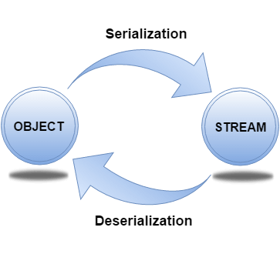
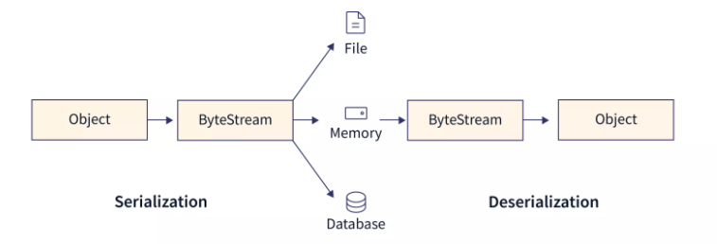
The serialization and deserialization process is platform-independent, it means you can serialize an object on one platform and deserialize it on a different platform.
For serializing the object, we call the writeObject() method of ObjectOutputStream class, and for deserialization we call the readObject() method of ObjectInputStream class.
We must have to implement the Serializable interface for serializing the object.

Advantages of Java Serialization
It is mainly used to trasfer object's state on the network (that is known as marshalling).
Example of Java Serialization
In this example, we are going to serialize the object of Student class
The writeObject() method of ObjectOutputStream class provides the functionality to serialize the object. We are saving the state of the object in the file named f.txt.
Methods of ObjectOutputStream Class
writeObject() method: Serializes the object, and writes it to ObjectOutputStream.
public final void writeObject(Object obj) throws IOException {}

close() : Closes a current stream.
public void close() throws IOException {}
flush(): Flushes the current output stream.
public void flush() throws IOException {}
import java.io.*;
import java.io.Serializable;

public class Student implements Serializable
{
int id;
String name;
public Student(int id, String name) {
this.id = id;
this.name = name;
}
}
class Persist{
public static void main(String args[]){
try{
//Creating the object
Student s1 =new Student(211,"ravi");
//Creating stream and writing the object
FileOutputStream fout=new FileOutputStream("f.txt");
ObjectOutputStream outs=new ObjectOutputStream(fout);
outs.writeObject(s1);
outs.flush();
outs.close();
System.out.println("success");
}catch(Exception e){System.out.println(e);}
}
}
Output:

Success

Deserialization

Methods of ObjectInputStream Class

readObject(): This method converts the stream of bytes to the state of the object. In other words, it reads an object from the input stream.

public final Object readObject() throws IOException, ClassNotFoundException{}

close(): As the name suggests, this method basically closes the Input stream.

public void close() throws IOException {}

import java.io.*;
class Depersist{
public static void main(String args[]){
try{
//Creating stream to read the object
ObjectInputStream ins=new ObjectInputStream(new FileInputStream("f.txt"));
Student s=(Student)ins.readObject();
//printing the data of the object
System.out.println(s.id+" "+s.name);
//closing the stream
ins.close();
}catch(Exception e){System.out.println(e);}
}
}
Output:
211 ravi
Enumerations (enum)
- An enumeration is a list of named constants
- Enum in java is a data type that contains fixed set of constants.
- It can be used for days of the week (SUNDAY, MONDAY, TUESDAY, WEDNESDAY, THURSDAY, FRIDAY and SATURDAY) , directions (NORTH, SOUTH, EAST and WEST) etc.
- The java enum constants are static and final implicitly.
- It is available from JDK 1.5. Java Enums can be thought of as classes that have fixed set of constants.
- In Java, an enumeration defines a class type
- An enumeration is created using the enum keyword.

class EnumExample1{
public enum Season { WINTER, SPRING, SUMMER, FALL }
public static void main(String[] args) {
for (Season s : Season.values())
System.out.println(s);
}}

Output:
WINTER
SPRING
SUMMER
FALL

- Once you have defined an enumeration, you can create a variable of that type.
- Enumerations define a class type, but it is not allowed to instantiate an enum using new.
- Instead, you declare and use an enumeration variable in much the same way as that of the primitive types.
- Two enumeration constants can be compared for equality by using the = = relational operator.
Enum and Constructor
- Enum can contain a constructor and it is executed separately for each enum constant at the time of the enum class loading.
- We can’t create enum objects explicitly and hence we can’t invoke the enum constructor directly.

// Java program to demonstrate that enums can have constructor.

enum Color {
RED,
GREEN,
BLUE;

// enum constructor called separately for each constant
private Color()
{
System.out.println("Constructor called for : " + this.toString());
}

public void colorInfo()
{
System.out.println("Universal Color");
}
}

public class Test {
// Driver method
public static void main(String[] args)
{
Color c1 = Color.RED;
System.out.println(c1);
c1.colorInfo();
}
}
Output
Constructor called for : RED
Constructor called for : GREEN
Constructor called for : BLUE
RED
Universal Color

All enumerations automatically contain two predefined methods:
- values( ) : The values( ) method returns an array that contains a list of the enumeration constants
- valueOf( ): valueOf( ) method returns the enumeration constant whose value corresponds to the string passed to its
Example:
enum Color {
RED,
GREEN,
BLUE;
}

public class Test
{
public static void main(String[] args)
{
// Calling values()
Color arr[] = Color.values();

// enum with loop
for (Color col : arr) {

System.out.println(col);
}
System.out.println(“value is”+Color.valueOf("RED"));
}
}

Output:
RED
GREEN
BLUE
value is RED

Type wrappers
wrapper classes are objects encapsulating primitive Java types.
What’s the purpose of a wrapper class?”. It’s one of the most common Java interview questions.
Basically, generic classes only work with objects and don’t support primitives. As a result, if we want to work with them, we have to convert primitive values into wrapper objects.
- In the Collection framework, Data Structures such as ArrayList HashSet, Vector, LinkedList, etc store data only as objects and not the primitive types.

primitive values needed to be manually converted to corresponding wrapper classes and stored in collections.

Autoboxing and Unboxing
In the previous section, we showed how to manually convert a primitive value to an object.
After Java 5, this conversion can be done automatically by using features called autoboxing and unboxing.
“Boxing” refers to converting a primitive value into a corresponding wrapper object. Because this can happen automatically, it’s known as autoboxing.
Similarly,
when a wrapper object is unwrapped into a primitive value then this is known as unboxing.
What this means in practice is that we can pass a primitive value to a method which expects a wrapper object or assign a primitive to a variable which expects an object:

